DIY GRATITUDE JAR

This makes a great “unofficial” gratitude journal and is so fun to look back on and see what you were grateful for on a specific day.

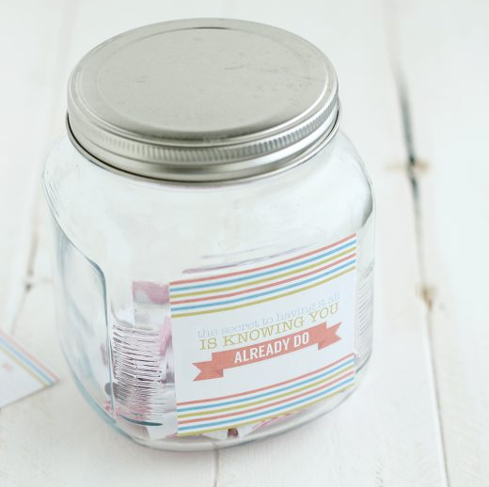

MATERIALS:
- Jar
- Slips of paper (e.g. Today I am grateful for…)
- Pen
- (Optional) decorations for the jar: glitter, stickers, beads etc

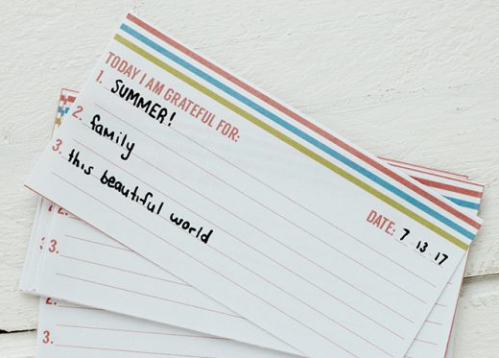

Instructions:

Each day fill out one of your slips of gratitude paper.

Once you’ve built up your jar, pick out a slip of paper to read at any time but especially when you need a lift.

